B39SB Time and Frequency Signal Analysis: Elements of Communication Systems

Tutorial 2
________________________________________________________________________________
Modulation theorem: if , then
Double-Sideband (DSB) Modulation: .
Phase Modulation (PM):
Frequency Modulation (FM):
________________________________________________________________________________

P1. A single-tone audio signal is modulated by a high-frequency carrier wave , where . Obtain and sketch the spectrum of the resulting DSB-modulated signal.

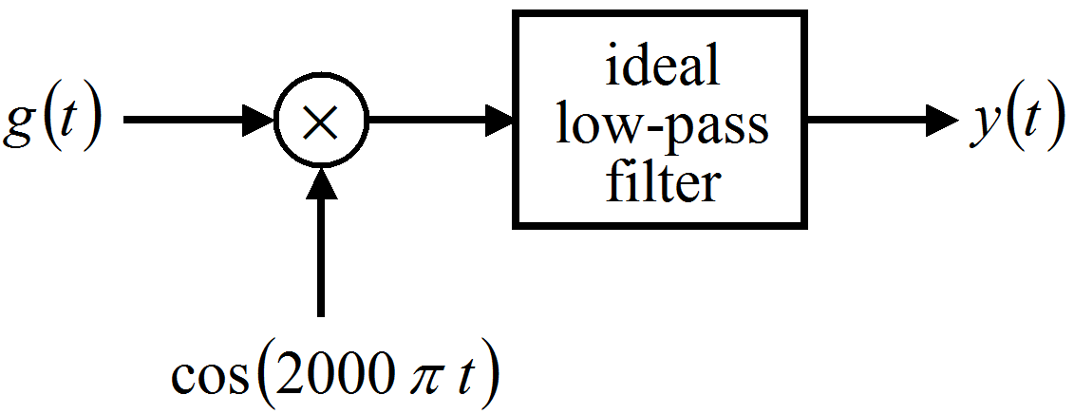

P2. Let be a real-valued signal with when . Amplitude modulation is performed to produce the signal . A proposed demodulation technique consists of multiplying the modulated signal by and passing through a lowpass filter with the cutoff frequency and passband gain of 2. Determine .

P3. Suppose and . If the product is passed through an ideal lowpass filter with cutoff frequency and passband gain of 2, determine the signal obtained at the output of the lowpass filter.

P4. A conventional AM signal is of the form , . Show that, to avoid distortions (if an envelope detector is used), .

P5. An interesting signal having a linearly varying frequency is the chirp signal. It is expressed in the general form as and has a phase given by . Such signals are called chirps because they sound like the chirp of a bird.
- For and , express in the sinusoidal form.
- Plot the instantaneous frequency versus time for the period .

P6. An angle-modulated signal is given by for . Let the carrier frequency be rad/s.
- If is a FM signal with , determine the modulating signal over .
- If is a PM signal with radians/volt, over .

